Hong Kong Exchanges and Clearing Limited and The Stock Exchange of Hong Kong Limited take no responsibility for the contents of this announcement, make no representation as to its accuracy or completeness and expressly disclaim any liability whatsoever for any loss howsoever arising from or in reliance upon the whole or any part of the contents of this announcement.

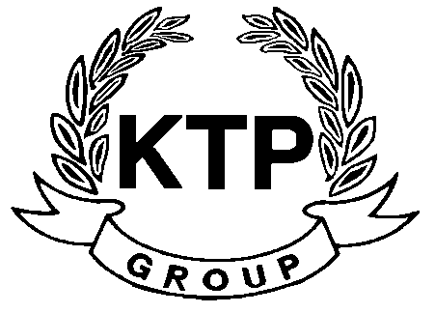
KTP HOLDINGS LIMITED
港台集團有限公司*
(Incorporated in Bermuda with limited liability)
(Stock Code: 645)

PROFIT WARNING

This announcement is made by the Company pursuant to Rule 13.09 of the Listing Rules.

The Board wishes to inform the Shareholders and potential investors that the Group is expected to record a significant decrease in the net profit attributable to Shareholders for the six months ended 30th September 2010 as compared to the same period in 2009.

Shareholders and potential investors are advised to exercise caution when dealing in the shares of the Company.

This announcement is made by KTP Holdings Limited (the “Company”, and together with its subsidiaries, the “Group”) pursuant to Rule 13.09 of the Rules Governing the Listing of Securities on The Stock Exchange of Hong Kong Limited (the “Listing Rules”).

The board of directors of the Company (the “Board”) wishes to inform the shareholders of the Company (the “Shareholders”) and potential investors that the Group is expected to record a significant decrease in the net profit attributable to Shareholders for the six months ended 30th September 2010 as compared to the same period in 2009. Based on the information currently available, the Board considers that the decrease is mainly due to the absence of one-off gain from disposal of subsidiaries which were recorded in the last corresponding period.

The Company is still in the process of finalising the Group’s interim results for the six months ended 30th September 2010. The information contained in this announcement is only based on the Company’s preliminary review of the management accounts of the Group, which have not been audited or reviewed by the Company’s auditors. Further details of the Group’s performance will be disclosed in the Group’s unaudited interim results for the six months ended 30th September 2010 to be announced on 24th November 2010.

Shareholders and potential investors are advised to exercise caution when dealing in the shares of the Company.

By Order of the Board
KTP Holdings Limited
Lee Chi Keung, Russell
Chairman

Hong Kong, 15th November 2010

As at the date of this announcement, the executive directors of the Company are Mr. Lee Chi Keung, Russell (Chairman), Ms. Yu Mee See, Maria and the independent non-executive directors are Mr. Ng Wai Hung, Mr. Lee Siu Leung and Mr. Yuen Sik Ming.

*For identification purpose only

